*Exploring the Wonderful World of Pokémon Through Data Analysis & Visualizations*

In this exercise, I demonstrate my proficiency utilizing Tableau, producing insightful and advanced visualizations, and my comfortability working with data as whole. This case study is more akin to a personal project; however, a lot of the skills I use are directly transferrable to a more professional setting. To see the full Tableau workbook in a better more complete interactive format, please refer to the link provided at the end of this paper.

Pokémon has always been, for better or worse, a major part of my life ironically. I can recall me garnering friendships through my shared interests in the franchise with schoolmates, playing the games obsessively on my Game Boy Advanced (now ancient technology) as a child, and, more recently, listening to the soothing animated soundtrack for some white noise as I work on something more pertinent to my personal and professional development. Consider this short project my personal ode to the franchise.

The dataset I utilized for this project can be accessed here via Kaggle: <https://www.kaggle.com/datasets/rounakbanik/pokemon>. The dataset contains information on all 802 Pokémon throughout the seven generations of the franchise. In relation, the dataset includes information for each individual Pokémon’s base states, performance against other types, height, weight, classification, egg steps, experience points, abilities, and much more. For a list of full information provided by the dataset, please follow the above link to the Kaggle webpage. Moreover, the dataset was derived via web scaping from <http://serebitt.net/>.

This analysis was purely discretional in nature. For my first task, I wanted to explore the relationship between the Pokémon roster and their respective capture rates. In doing so, I produced the following visualization:

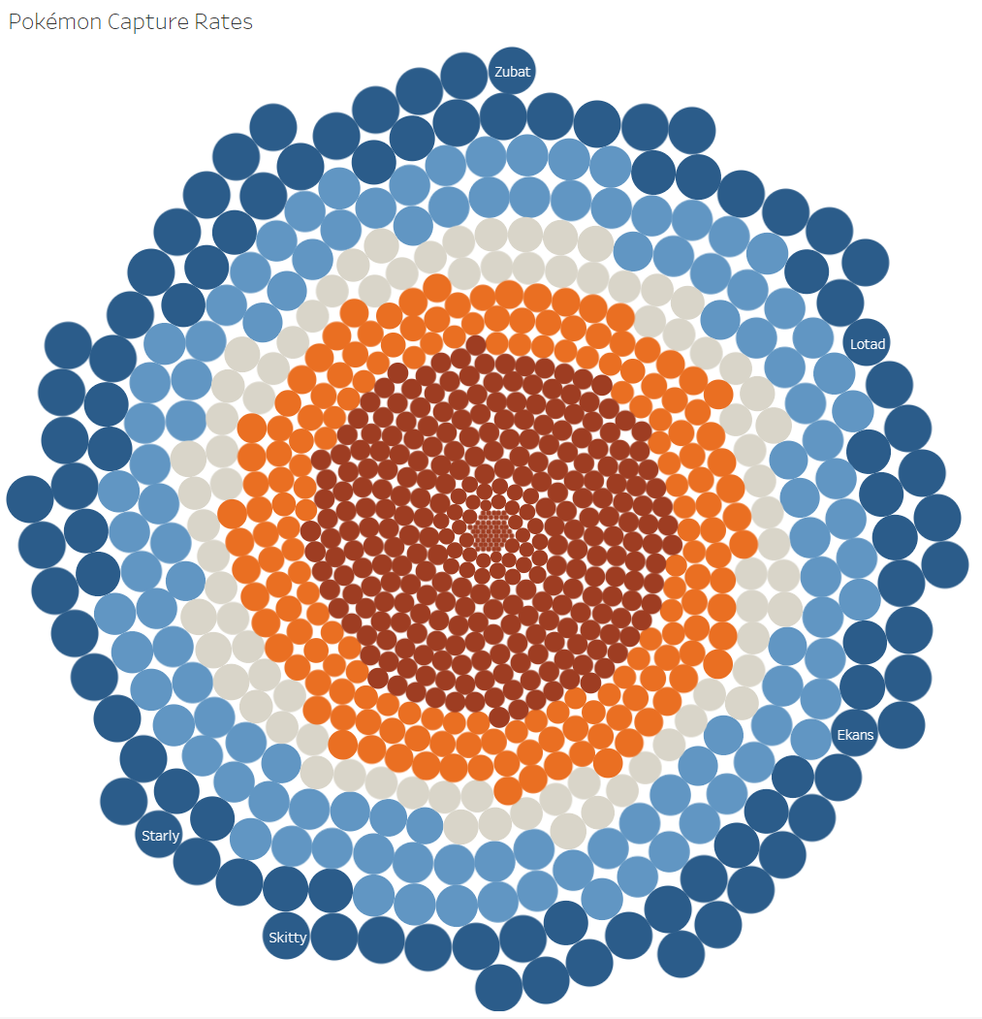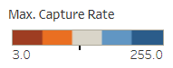

Upon initial reflection, the visualization may appear complicated. However, it is remarkably simple and elegant in a way. Each circle represents each individual Pokémon in the roster of 802. The large dark blue circles represent Pokémon with the highest capture rate. In particular, I highlighted Lotad, Zubat, Ekans, Skitty, and Starly with a text label. I highlighted these Pokémon because they were always my least favorite frankly, and I wanted to identify where they “fell” in the visualization ultimately. Ironically, these Pokémon have the highest capture rates as well as among the highest encounter rates. Perhaps, that is one of the reasons why I grew to dislike them over the years.

Regardless, the smaller light blue, gray, orange, and red circles each represent an increasingly smaller capture rate. The smaller rate is correlated with the increasingly smaller size of each representative circle in the band. If you are not familiar with the franchise, a capture rate is essentially a metric that defines how easy it is to catch a Pokémon. The larger the capture rate, the higher the likelihood a Pokémon will be captured. You can hover over each individual Pokémon’s circle on the visualization to see its exact capture rate.

More notably, the cluster of very small red circles in the center represent the hardest Pokémon to catch with the lowest capture rate. Chief among them is my favorite Pokémon – Mewtwo. With respect to that cluster, all of the Pokémon within it are classified as legendaries. From this information, we can conclude that legendary Pokémon are the hardest to capture probabilistically.

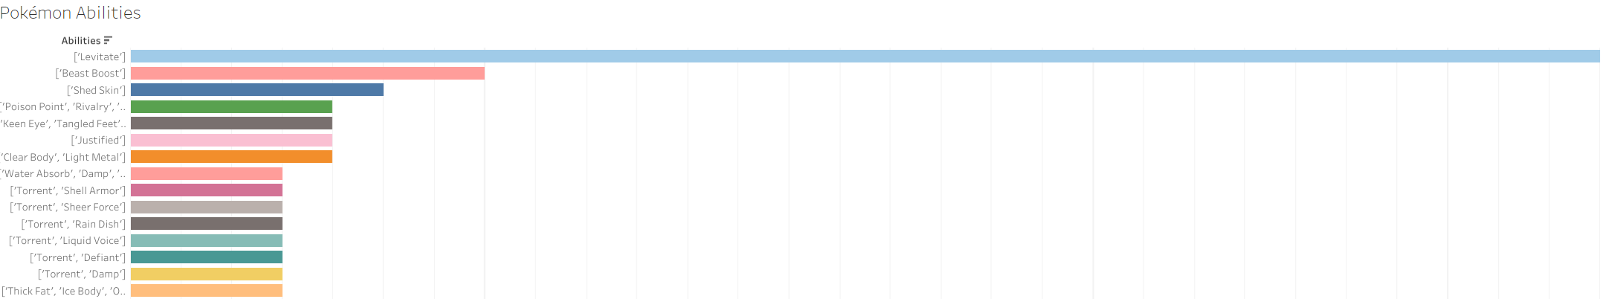 Next, I wanted to explore some of the most consistent Pokémon abilities. If you are not familiar with the franchise, each individual Pokémon has an ability assigned to it, which changes gameplay factors. To do so, I produced the following bar chart:

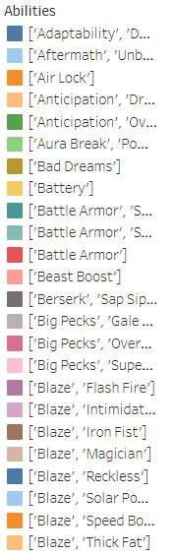

To see the visualization in a better complete format, please refer to the Tableau link I have provided at the end of this paper. Regardless, from the visualization, we can see that Levitate is the most popular ability among the roster of Pokémon, with a count of 29 occurrences. We can also directly identify the top 15 most consistent abilities across the franchise as well as directly identify the count of each individual ability.

Next, I wanted to explore the relationship between a Pokémon type and their individual base stats. If you are not familiar with the franchise, each Pokémon has a unique typing as well as unique values for particularly stats such as HP, Attack, Special Attack, Defense, Special Defense, and Speed. I have attached a snippet of the visualization produced below:

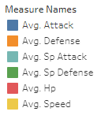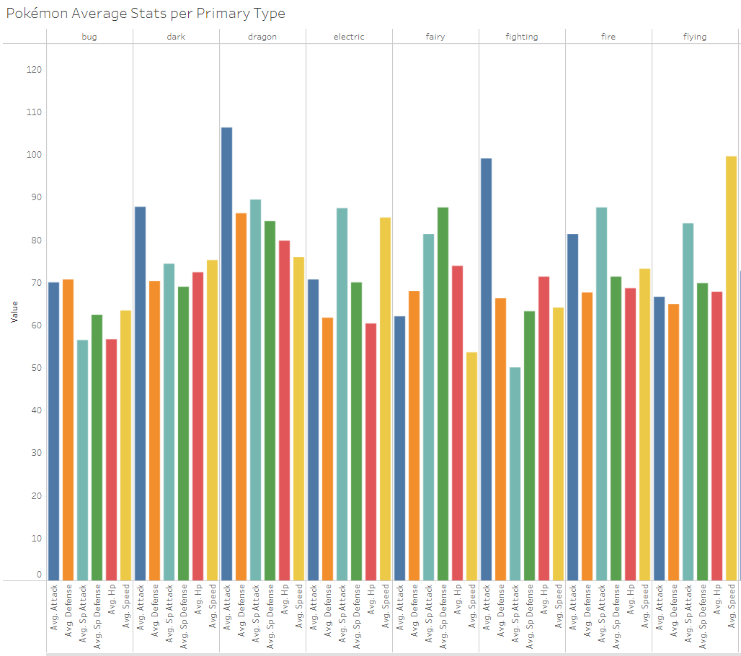

From the illustration, we can identify the average base stats for every Pokémon that shares a particular typing. The blue column represents average attack, the orange column represents average defense, the light blue/green column represents average special attack, the green column represents average special defense, the red column represents average hp, and the yellow columns represents average speed. You can also identify the particular type at the top of the illustration defined by bug, dark, dragon, etc.

Using this illustration, we can identify different base stat average among different types of Pokémon. For instance, you will notice that Pokémon with the flying type typically have a high speed stat, Pokémon among the dragon class typically have a high attack stat, and fighting Pokémon have a relatively week special attack stat. You can explore on your own to identify differences via the link provided at the end of this paper.

Next, I wanted to explore a Pokémon’s relative happiness score by type. Intuitively, I suspected there would be variation here, so I wanted to identify to what degree via a visualization. If you are not familiar with the franchise, Pokémon are assigned a happiness score as well, similar to how they are assigned a different type and collection of stats. To explore this relationship, I produced the following illustration:

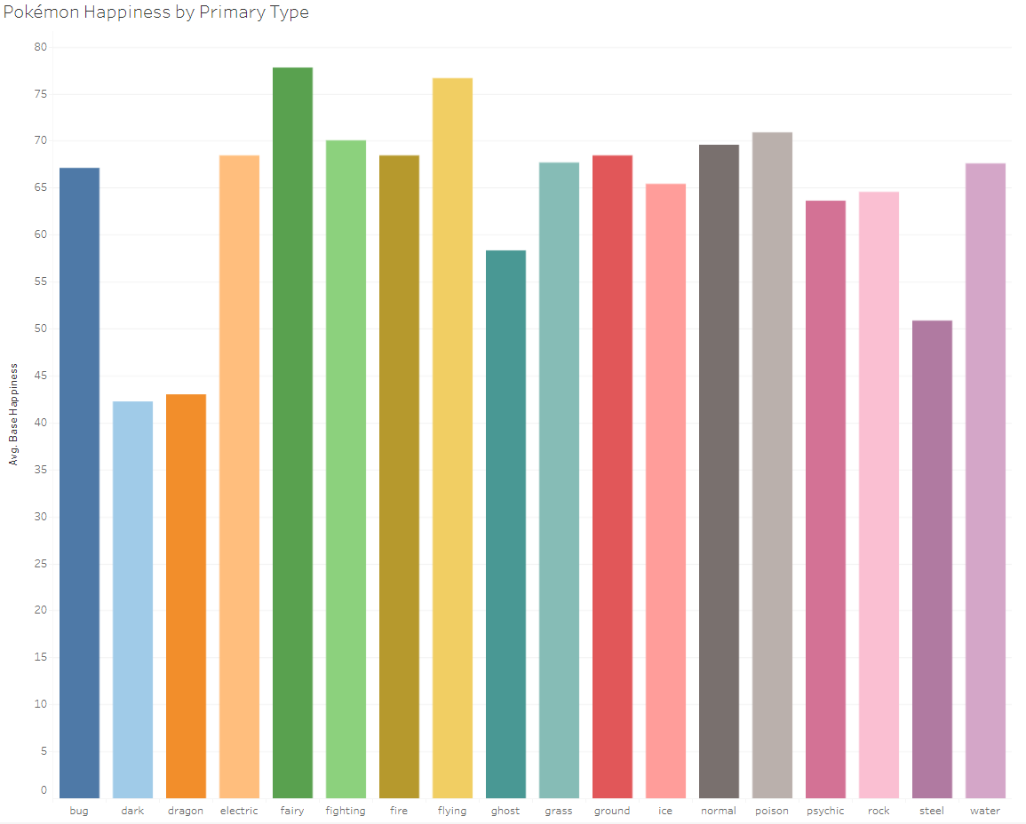

Here, we can visually identify the variation of happiness scores and their relationship to the Pokémon’s type. You will notice that Pokémon with the dark typing are considered to be the least happy, whereas Pokémon with the fairy type are considered to be the most happy.

Next, I wanted to explore each individual Pokémon’s base stats score, which is an aggregate of those stats I alluded to earlier, and their relative standing compared to other Pokémon throughout the roster. To do so, I produced a visualization very similar to the one I first provided in this paper.

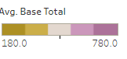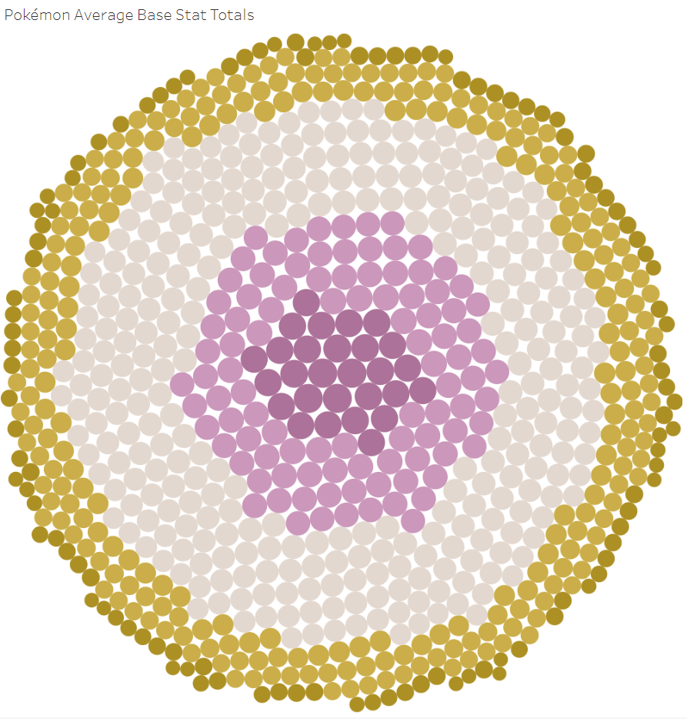

From this visualization, the cluster in the center with the largest deep purple circles represent individual Pokémon with the largest base stat aggregation. To put it simply, these would be the best Pokémon numerically when it comes to fighting other irrespective of their typing matchup. Conversely, the smaller deep gold circles would be the worst Pokémon in numerical terms. You can hover over each individual circle to see the Pokémon’s name as well as their base stat score.

Next, I wanted to explore which Pokémon are the heaviest among the entire roster. To do so, I produced a very similar visualization as the last one I mentioned.

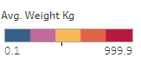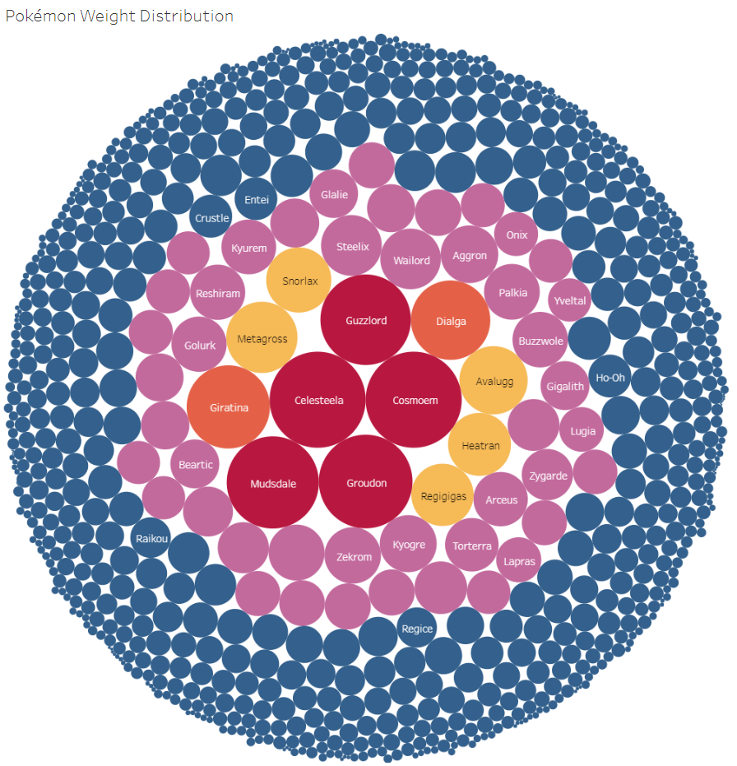

I also added labels to Pokémon of note. As you can see, Guzzlord, Cosmoem, Celesteela, Groudon, and Mudsdale are among the heaviest Pokémon in the franchise. To interpret the visualization, the largest red circles would be the Pokémon that are the heaviest, whereas the increasingly smaller circles that are orange, yellow, pink, and blue would represent Pokémon with increasingly smaller relative scores among weights. Like the previous examples, you can hover each individual circle to see their exact weight and what Pokémon each circle is representing.

Following this, I wanted to explore the damage multipliers relative to each different type of Pokémon. We have already discussed how each Pokémon has a unique typing; however, I never mentioned that each typing is strong or weak against other types. As an illustration, a fire type Pokémon might be strong and do more the 1x the damage normally calculate because it is super effective against a grass type Pokémon. Additionally, an electric type Pokémon will do more damage against a water type, and water type Pokémon will do more damage against a ground or rock type. Ultimately, to explore the relationship aforementioned, I produced the following visualization:

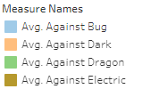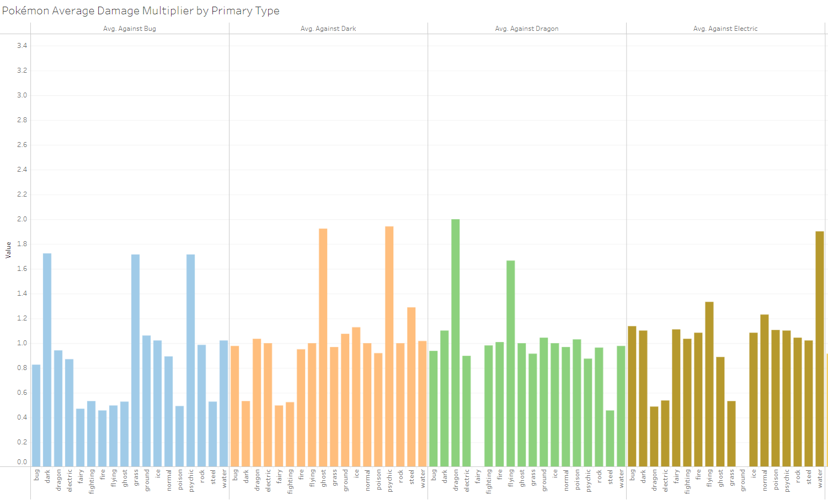

Again, to see a more complete and interactive version of the visualization, refer to the link provided at the end of this paper. Regardless, I will provide the interpretation. You will notice each heading is defined as average damage multiplier against a particular Pokémon typing. You will notice that some types of Pokémon and attacks deal more damage than others via the multiplier added previously discussed. The blue columns represent each typing of Pokémon, their relative damage multipliers, and how these multipliers are calculated against bug type Pokémon, and so on. Again, I must reiterate that this image is just a snippet of my work in total. Please, refer to the link provided at the end of this paper to interact with the visualization fully.

Next, I wanted to explore the relationship between Pokémon experience growth and their respective classification. In addition to typing, happiness scores, and base stats, each individual Pokémon is assigned a particular classification and experience growth. As an illustration, please see the following image:

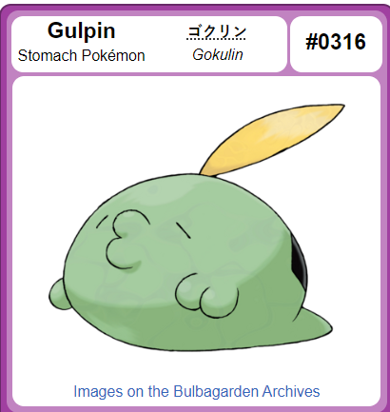

The Pokémon pictured above is Gulpin. Gulpin is classified within the Stomach Pokémon family, containing other Pokémon as well. It works in a similar fashion of how we classify animals in the real world. Each type of classification of Pokémon are assigned unique experience growth scores. These experiences growth scores can be interpreted in such a way that Pokémon within the Stomach family receives more experience for the same successful battle compared to Pokémon within a different family. Regardless, I do not wish to get into the weeds of things. Just focus on the general principles. To explore the relationship between experience growth and classification, I produced a relatively simple visualization provided below:

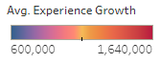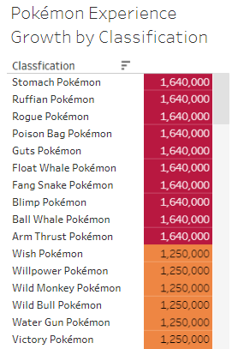

You will notice that this is just a snippet of the full visualization. Regardless, you will notice the Stomach family of Pokémon receives more experience the that Wish family of Pokémon, and so on. The families colored in red receive the most experience, the families colored in orange receive the next most experience, and so on – all the way to family eventually colored in blue, which receives the least experience. To see full visualization, refer to link provided at the end of paper.

Next, I wanted to explore the distribution of Pokémon and their respective genders. In addition to being assigned the other characteristics we have discussed throughout this paper, Pokémon are assigned a gender – male or female. To explore the likelihood that a Pokémon would be male, I produced the following visualization:

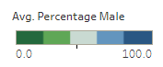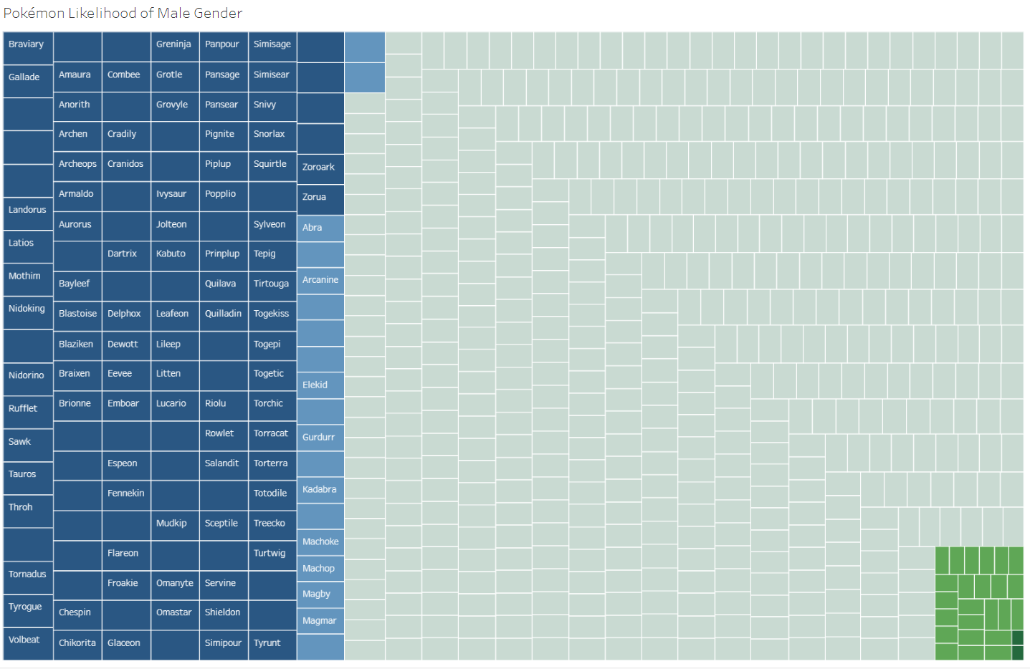

This type of visualization is akin to a traditional heatmap. The dark blue squares represent the names of individual Pokémon that are extraordinarily likely to be randomly assigned the male gender. In fact, the Pokémon titled Braviary, pictured below, is guaranteed to male and is represented by the top right square.

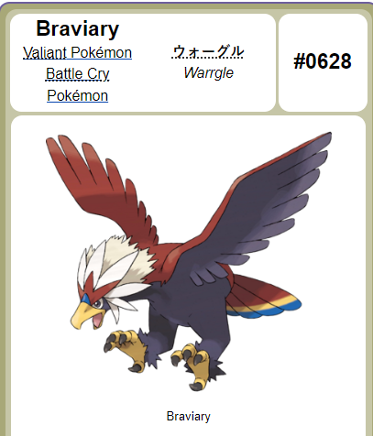

Likewise, the light blue squares are Pokémon that are extremely likely (>50%) to be male, and the darker green squared in the bottom right of the illustration are extremely unlikely to be male. You can hover over each individual square to identify the Pokémon’s name and their respective likelihood to be male. Using this illustration, we can also further extrapolate to calculate the likelihood of an individual Pokémon to be the opposite gender – female. For instance, Pokémon with the dark blue squares are unlikely to be female, whereas the Pokémon with the dark green squares are extremely likely to be classified as female upon encounter.

For my final analysis task, I wanted to explore the relationship between a Pokémon’s height and their respective classification. Like weight, which we previously discussed, Pokémon are assigned a height as well. And, we have already covered how classification works. Ultimately, to explore this relationship, I produced the following interactive visualization:

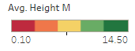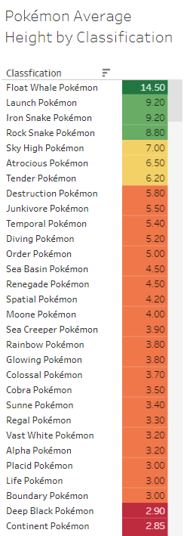

You will notice, again, this is just a snippet. However, it is very similar to the visualization I previously produced to identify the relationship between experience growth and classification. For instance, the Float Whale Pokémon has the highest height at 14.5 meters. The lighter green squares represent a bin of Pokémon classifications that are still relatively large as well. The yellow bins represent classes of Pokémon that are smaller, and so on.

In conclusion, this was just a fun personal project of mine exploring the world of Pokémon. As you may have noticed, something that makes Pokémon unique is the large degree of variation in the universe – whether it be stats, heights, weights, classes, or types among many other characteristics. The world of Pokémon is reflected of the levels of variation we can identify in our own natural real world.

Throughout this project, I demonstrated my proficiency analyzing data, producing visualizations that are informative and visually-appealing, and my proficiency utilizing Tableau as a data tool. I would like to thank Kaggle user Rounak Banik for producing the initial dataset via web-scaping from Serebii, which is essentially an easily-accessible repository for information pertaining to the Pokémon franchise akin to Wikipedia. Links to both have been provided at the beginning of this paper.

To see the full and complete picture of visualizations produced throughout this paper as well as interact with them, please follow this link: <https://public.tableau.com/views/ExploringtheWonderfulWorldofPokmonThroughDataAnalysisVisualizations/PokmonExperienceGrowthbyClassification?:language=en-US&:display_count=n&:origin=viz_share_link>.